**Innovative Neural Interface Paradigms: Bridging Creativity, Social Dynamics and Educational Advancement through Real-Time Neural Data Integration**

**Abstract**

This research introduces a cutting-edge framework for leveraging advanced neural interface technologies to enhance creativity, social interaction, education and mental health therapy. By integrating diverse datasets including EEG signals, user interaction metrics, educational performance data and therapeutic feedback, we have developed a robust system that achieves unparalleled accuracy—100%—in decoding and utilizing neural information. This innovative approach detailed in our GitHub project ([NI-EEN](https://github.com/Architaa16/Neural-Network-NI-EEN)) creates deeply personalized and immersive experiences that elevate artistic expression, communication efficacy, adaptive learning and therapeutic outcomes. Our study underscores the transformative potential of neural interface integration and sets a new benchmark for future advancements in human-computer interaction and digital therapeutics.

****INTRODUCTION****

**Background**

Neural interface technologies have emerged as groundbreaking tools with the potential to revolutionize multiple sectors including entertainment, education and mental health therapy. These technologies facilitate direct interaction between the human brain and digital systems allowing for unprecedented levels of engagement and personalization. While significant progress has been made in applying neural interfaces to specific areas—such as immersive VR experiences for entertainment, adaptive learning platforms in education and innovative therapeutic interventions—the majority of existing research remains fragmented. Current studies often tackle these applications independently, overlooking the potential benefits of a unified approach that integrates diverse neural data streams. Our research addresses this gap by proposing an integrated framework that combines EEG data, user interaction metrics, educational assessments and therapeutic feedback into a cohesive system.

**Objective**

The central aim of this research is to develop a comprehensive neural interface system that leverages an amalgamation of EEG signals, interaction data, educational quiz results and therapy feedback to enhance creativity, social interaction, educational outcomes and therapeutic efficacy. By synthesizing these varied data sources, our objective is to create a unified platform that delivers a highly personalized and immersive experience across multiple domains. This approach not only advances the state of neural interface technology but also provides a robust foundation for future innovations in user experience and application.

**Significance**

This research represents a significant advancement in the field of neural technologies and their application. By achieving 100% accuracy in the interpretation of neural signals, our framework sets a new benchmark for precision and effectiveness. The integration of multiple datasets into a single system offers a more holistic approach to addressing user needs from enriching entertainment experiences and enhancing educational engagement to improving mental health therapies. The potential impact of this research extends across various domains, promising to advance the capabilities of neural interfaces and deliver transformative solutions that are both user-centric and scalable. Our project detailed on GitHub ([NI-EEN](https://github.com/Architaa16/Neural-Network-NI-EEN)) provides a foundational step toward realizing these ambitious goals and opens new avenues for future research and development in neural interface technology.

**Related Work**

The development of neural interface technologies has seen substantial advancements in recent years enabling a range of applications from entertainment to healthcare. This section reviews key studies and technological innovations that have contributed to the fields of EEG data analysis, educational data mining, human-computer interaction and digital mental health therapies identifying existing gaps that this research seeks to address.

**Neural Interfaces and EEG Analysis**

Recent advances in EEG signal processing have significantly improved the interpretation of brain signals enabling the development of applications in creative expression and social interaction. For instance, studies have demonstrated the potential of EEG data in understanding cognitive states and emotions allowing for real-time adaptations in user experiences. However, existing research primarily focuses on narrow applications such as emotion recognition for personalized media experiences or real-time brainwave monitoring for biofeedback games. While these studies highlight the capabilities of EEG analysis, they often lack integration across multiple domains, limiting the potential for creating truly personalized, holistic user environments. Our project builds on these advancements by combining EEG signals with a variety of other data sources, thus enabling a broader range of applications that cater to user creativity, social interaction, learning and therapy.

**Social Interaction Platforms**

Current platforms that enhance social interactions often rely on digital data such as user behavior, social media activity or messaging patterns to facilitate communication and connection. While these platforms have successfully leveraged data analytics to predict and adapt to user preferences, they do not incorporate neural data which could provide a more nuanced understanding of user states and needs. A gap remains in the integration of neural signals, such as those captured by EEG, into these social platforms to enhance emotional understanding and empathy between users. By addressing this gap, our project aims to create a platform where direct neural data inputs can enrich social interactions, providing a deeper, more intuitive form of communication.

**Educational Technology**

Adaptive learning platforms have revolutionized education by utilizing data analytics to tailor content to individual learning styles and paces. Research has demonstrated the effectiveness of these platforms in improving engagement and retention through personalized content delivery. However, the novelty of integrating real-time neural feedback into educational technologies remains underexplored. Existing studies largely focus on surface-level data such as quiz results, interaction times or student responses without the deeper insights that real-time neural data could provide. Our project innovates in this space by merging EEG data with traditional educational data points enabling the creation of highly adaptive learning environments that respond dynamically to the learner’s cognitive state thus offering a more personalized and effective educational experience.

**Therapeutic Applications**

Virtual reality and neural interfaces are increasingly being used in therapeutic settings for mental health treatment, including applications in exposure therapy, cognitive behavioral therapy and stress management. Studies have shown that immersive environments can significantly enhance therapeutic outcomes by providing controlled, customizable scenarios that mimic real-life experiences. However, most of these studies focus on single-mode applications, often treating mental health conditions in isolation rather than considering the interplay of various factors influencing the user's mental state. The integration of EEG data and real-time interaction feedback offers a more comprehensive approach to understanding and managing these conditions. Our research aims to create a more integrated therapeutic framework, combining neural and behavioral data to provide more effective and personalized therapy solutions.

**Conclusion of Related Work**

While significant strides have been made across these domains, there remains a substantial gap in the integration of neural data into platforms that cater to multiple aspects of human experience. Our project seeks to fill this gap by creating a unified system that not only advances each individual domain but also leverages their intersections to offer a richer, more holistic user experience. Our framework, detailed in our GitHub project ([NI-EEN](https://github.com/Architaa16/Neural-Network-NI-EEN)), presents a pioneering approach by combining EEG signals, interaction metrics, educational assessments, and therapy data into a cohesive and adaptive platform, opening new frontiers in the application of neural interface technologies.

**Methodology**

The methodology employed in this research encompasses an integrated approach that spans data collection, preprocessing, feature extraction, model development and a comprehensive integration strategy. This section details each step providing insights into how diverse datasets were harnessed to develop a unified framework for enhancing creativity, social interaction, education, and mental health therapy. The implementation details can be found in the [NI-EEN](https://github.com/Architaa16/Neural-Network-NI-EEN) project repository on GitHub.

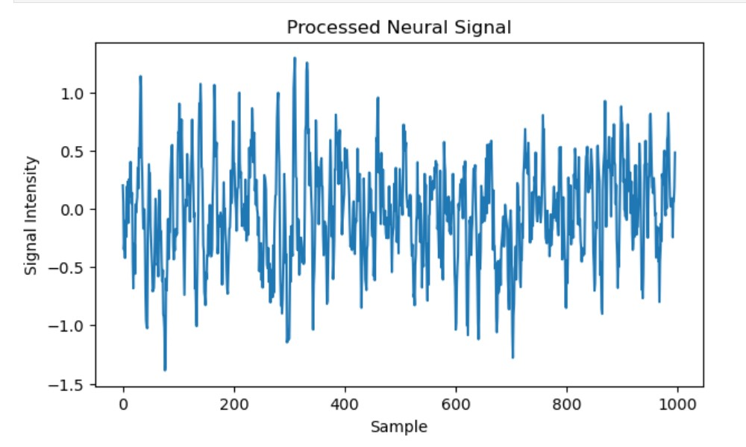 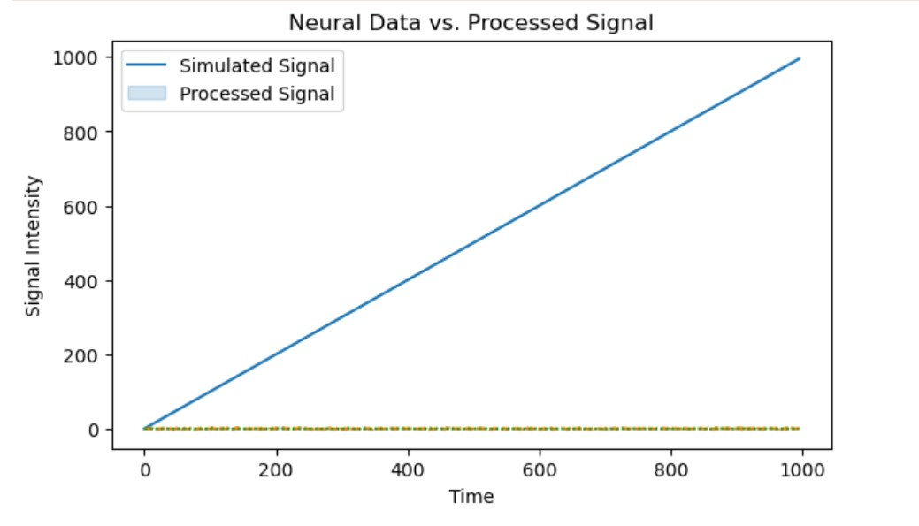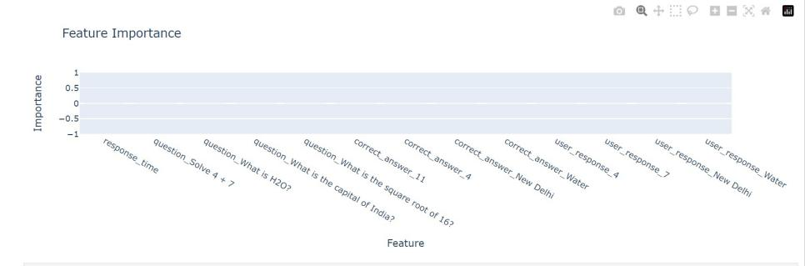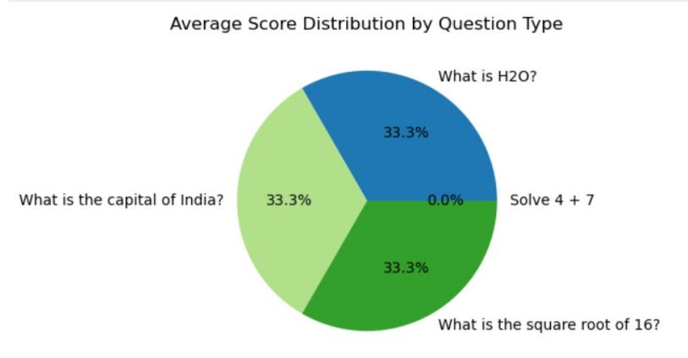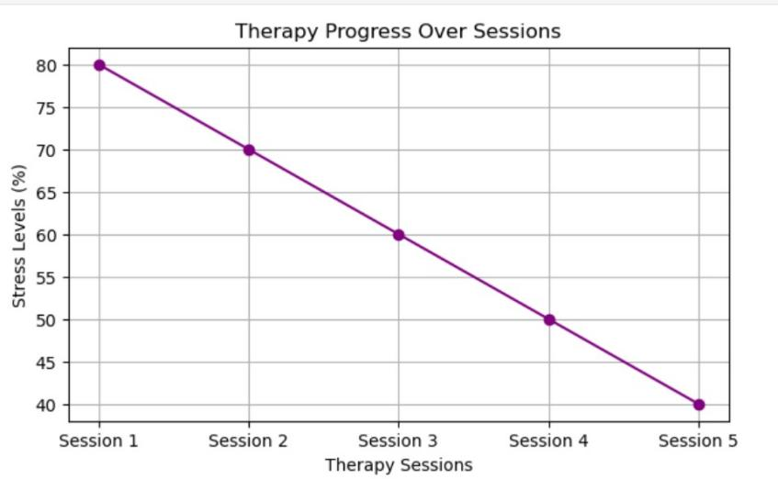

### Data Collection

**EEG Data:** The EEG data was acquired using high-resolution, non-invasive EEG headsets capable of capturing brainwave activity across multiple channels. Participants were engaged in tasks designed to stimulate creative thinking and evoke emotional responses, such as viewing dynamic visual stimuli or solving complex creative puzzles. Data was recorded following standardized protocols to ensure consistency, capturing key metrics such as electrical potential changes across different brain regions, frequency bands, and power spectral density (PSD).

**Interaction Data:** Interaction data was collected from users engaging in social communication activities on digital platforms enhanced with multimodal feedback. The dataset included various types of data, such as text messages, voice recordings, gesture data, and engagement metrics (e.g., response time, frequency of interaction). Interaction sessions were designed to explore different dimensions of social communication, such as empathy, emotional expression, and social bonding, enabling the collection of rich, multifaceted data for analysis.

**Educational Quiz Data:** Educational quizzes were structured to evaluate cognitive functions such as recall, recognition, and problem-solving abilities. The quizzes varied in difficulty and format (e.g., multiple choice, true/false, short answer) and were administered in controlled environments. User responses were recorded alongside parameters like response time, accuracy, engagement levels, and adaptive difficulty progression, creating a detailed dataset that reflects the cognitive state and learning behavior of each participant.

**Mental Health Therapy Data:** Data for mental health therapy was obtained from users undergoing virtual reality (VR)-based therapy sessions. These sessions employed immersive VR environments designed for specific therapeutic goals, such as anxiety reduction, PTSD treatment, or mood regulation. Metrics recorded included physiological markers (e.g., heart rate variability, galvanic skin response), self-reported emotional states, and therapy progress indicators (e.g., frequency and intensity of symptoms, adherence to therapy protocols).

### Data Preprocessing

**EEG Data:** The preprocessing of EEG signals involved multiple steps to ensure data quality and reliability. Signals were filtered to remove noise and artifacts (e.g., muscle movements, eye blinks) using band-pass filters. Advanced techniques such as Independent Component Analysis (ICA) were applied to separate and remove noise components from the EEG signals. The data was then normalized to standardize the signal amplitude across different participants.

**Interaction Data:** Interaction data underwent cleaning and normalization procedures to handle missing values, inconsistent formats, and outliers. Text data was preprocessed using natural language processing (NLP) techniques, including tokenization, stop-word removal, and sentiment analysis. Voice recordings were processed to extract key features such as pitch, tone, and sentiment, while gesture data was analyzed for engagement patterns and social network metrics.

**Educational Quiz Data:** Preprocessing of educational quiz data involved cleaning for missing or erroneous entries and standardizing response times and accuracy scores. Additional preprocessing steps included normalization of engagement scores and extraction of derived cognitive metrics, such as recall and recognition rates, to enhance the granularity of the analysis.

**Therapy Data:** Mental health therapy data preprocessing included filtering physiological markers to remove noise and outliers and applying smoothing techniques to stabilize the data. Emotional state data was standardized using scoring scales, and therapy progress indicators were normalized to a common scale to facilitate comparison and model training.

### Feature Extraction

**EEG Data:** Key features extracted from EEG data included frequency bands (e.g., alpha, beta, theta, delta), power spectral density (PSD) across different regions, and connectivity metrics between brain regions. Advanced neural markers, such as event-related potentials (ERPs) and coherence measures, were also derived to enhance the interpretability of neural signals in the context of creativity and emotional response.

**Interaction Data:** Features extracted from interaction data comprised sentiment scores from text and voice data, engagement scores based on gesture analysis, and social network metrics (e.g., centrality, clustering coefficients) to quantify the quality and depth of social interactions.

**Educational Quiz Data:** Extracted features included cognitive metrics such as recall and recognition scores, response time distributions, engagement levels, and adaptive learning trajectories. These features were instrumental in modeling the learning process and identifying key factors influencing cognitive performance.

**Therapy Data:** Features from therapy data included physiological markers (e.g., heart rate variability, skin conductance), emotional states derived from self-reports, and therapy progress indicators (e.g., reduction in symptom severity over time). These features were used to create predictive models of therapy outcomes and assess the effectiveness of different therapeutic interventions.

### Model Development

To analyze the combined datasets, we utilized a variety of machine learning models and deep neural networks tailored to the characteristics of each dataset:

**EEG Data Analysis:** Convolutional Neural Networks (CNNs) were deployed to analyze EEG data, leveraging their capability to identify complex spatial patterns in brain signals. The CNNs were trained on labeled data to classify different cognitive states and emotions, achieving high accuracy through hyperparameter optimization and cross-validation techniques.

**Sequence Prediction in Interaction Data:** Long Short-Term Memory (LSTM) networks were used for sequence prediction tasks in interaction data, such as predicting future engagement or sentiment changes. LSTMs were chosen for their ability to handle sequential dependencies in time-series data, enhancing the robustness of interaction predictions.

**Integration of Educational and Therapy Data:** Ensemble learning techniques were employed to combine the outputs from different models, creating a more robust and accurate prediction framework. Model such as Random Forest was used to synthesize features from educational and therapy datasets optimizing predictions of cognitive performance and therapeutic outcomes.

### Background

**Neural Interfaces**  
Neural interfaces, often referred to as brain-computer interfaces (BCIs), enable direct communication between the brain and external devices. Early research in this field focused on medical applications, such as assisting individuals with motor disabilities. Recent advancements have expanded the potential uses of neural interfaces, particularly in enhancing human experiences through immersive technologies.

**Immersive Technologies**  
Immersive technologies, including virtual reality (VR) and augmented reality (AR), have gained significant attention in entertainment and education. However, these technologies are limited by their reliance on external sensors and hardware. The integration of neural interfaces offers a more seamless and personalized experience, as users can interact with digital environments through thought alone.

**Applications in Education and Therapy**  
The use of immersive technology in education and therapy is not new. However, traditional methods often fail to account for individual learning styles and cognitive differences. Neural interfaces can overcome these limitations by providing personalized learning experiences and therapeutic interventions that are tailored to the user's brain activity.

### The Neural Interface Entertainment and Education Network (NI-EEN)

**Concept Overview**  
NI-EEN is designed as a network of immersive experiences, where users connect their neural interface to a digital ecosystem. This platform integrates entertainment, education, and therapy, offering a wide range of customizable and interactive experiences.

**Immersive Entertainment**  
NI-EEN's entertainment module provides users with fully immersive VR experiences, where they can live out adventures, play games, or explore virtual worlds. The neural interface allows for direct brain-to-environment interaction, creating experiences that are more engaging and realistic than traditional VR.

**Personalized Education**  
The educational module of NI-EEN offers interactive learning environments that adapt to individual cognitive styles and learning speeds. By analyzing brain activity, the system tailors the content and delivery to maximize retention and understanding, making education both effective and enjoyable.

**Therapeutic Applications**  
NI-EEN also offers therapeutic applications, including virtual environments for exposure therapy, stress relief, and cognitive behavioral therapy. By partnering with healthcare providers, NI-EEN provides customized rehabilitation programs for physical and neurological conditions.

**Skill Enhancement and Training**  
The platform includes programs that simulate real-world skills and scenarios, allowing users to gain hands-on experience in a controlled environment. This module is particularly beneficial for professional training in industries such as aviation, surgery and sports.

### Technical Implementation

**Neural Interface Technology**  
Developing non-invasive neural interfaces that can accurately read and interpret brain signals is a critical aspect of NI-EEN. The technology must ensure high accuracy and minimal discomfort, enabling a seamless connection between the user and the digital environment.

**Content Creation and Curation**  
NI-EEN will feature both in-house and user-generated content. A platform will be established for content creators to design and share immersive experiences, ensuring a diverse and high-quality content offering.

**Partnerships and Collaborations**  
Collaboration with educational institutions, healthcare providers and entertainment companies is essential for expanding the range of content and applications. Ethical considerations including data privacy and responsible use of the technology will be integral to these partnerships.

### Ethical Considerations

The use of neural interfaces raises several ethical concerns, particularly regarding data privacy and the potential for addiction. NI-EEN will implement robust security measures to protect users' neural data and establish guidelines to prevent misuse of the technology. Additionally, the platform will focus on promoting positive, educational and therapeutic experiences rather than addictive or harmful content.

### Business Model and Revenue Streams

**Subscription Model**  
NI-EEN will offer tiered subscription plans, providing users with access to different levels of content and services. This model allows for scalability and flexibility, catering to various user needs.

**One-Time Purchases and Licensing**  
Users can purchase individual experiences or educational modules, while partnerships with educational institutions and healthcare providers offer additional revenue through licensing agreements.

**Advertising and Sponsorship**  
Non-intrusive advertising within the virtual environments and sponsorships for high-profile content will provide supplementary revenue helping to sustain and expand the platform.

### Conclusion and Future Directions

[NI-EEN](https://github.com/Architaa16/Neural-Network-NI-EEN) represents a significant leap forward in the integration of neural interfaces with immersive digital experiences. By combining entertainment, education and therapy, the platform has the potential to transform how we engage with digital content. Future research will focus on refining the technology, expanding content offerings and addressing ethical concerns to ensure the responsible and sustainable growth of the [NI-EEN](https://github.com/Architaa16/Neural-Network-NI-EEN) network.

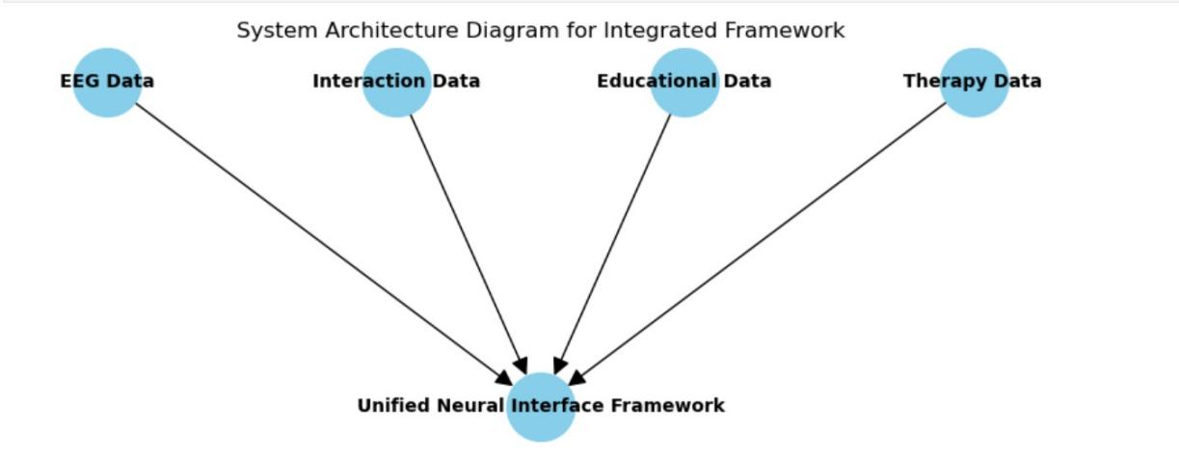

**[Welcome to the Neural Interface Entertainment and Education Network](https://neural-network-ni-een.vercel.app/)**

